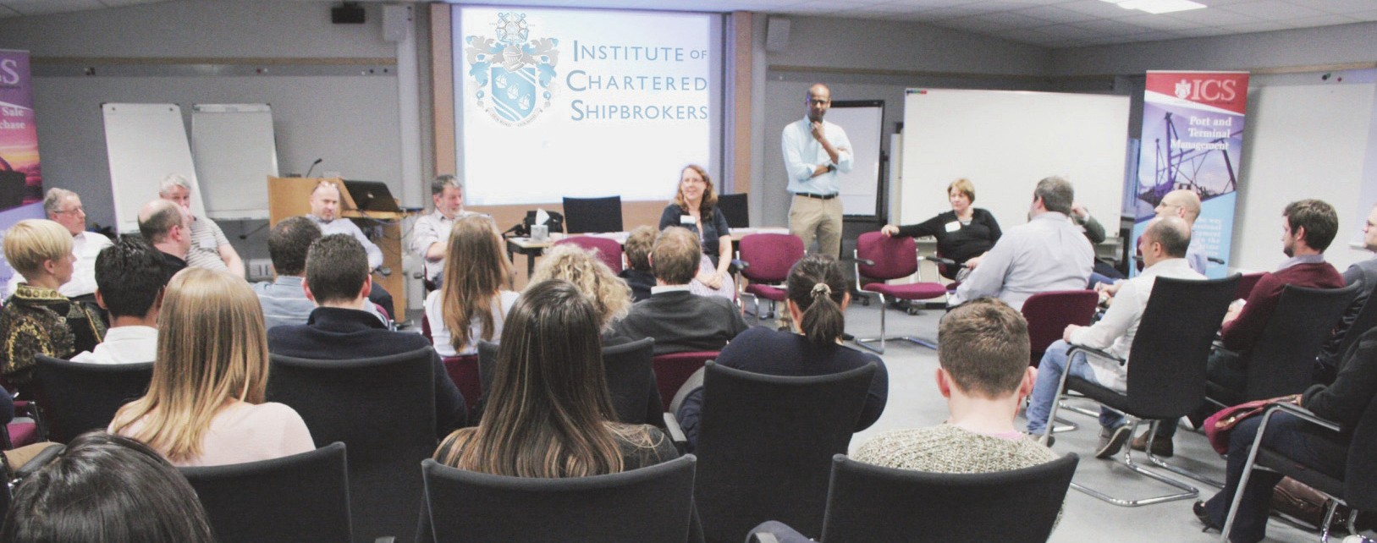

**Autumn PREP 2017**

Saturday 7th and Sunday 8th October 2017 - Devonport House, Greenwich, London SE10 9JW

# A study experience tailored specifically towards preparation for the Institute of Chartered Shipbrokers’ exams, open to all students irrespective of their method of study.

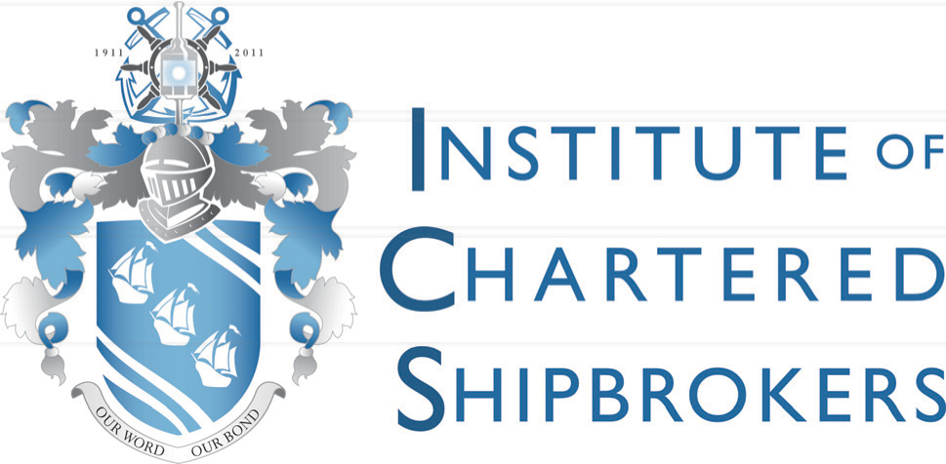

PREP provides students with an intensive, interactive and highly motivating study experience tailored specifically towards preparation for the Institute’s exams.

The two day revision event will include: mock exam, lectures, the opportunity for personal tutoring and networking.

*‘I thoroughly enjoyed the weekend, both learning and socialising. I feel much more confident about passing my exams and I hope to be back next year.’*

*Ricky, Clarksons Port Services*

*‘It was a perfect weekend of learning and socialising with colleagues from the industry. Will definitely come back next year as it is a great way to prepare toward my exams.’*

*Jordi, Next Maritime Agency*

*‘I thoroughly enjoyed the PREP weekend. It exceeded my expectations for both the facilities,*

*the accommodation we stayed in and also the amount and quality of the information given out by the presenters and the Institute’s staff who made themselves available throughout the weekend. Can’t wait for next year.’*

*Mark, The Armitt Group*

*‘Everything about this year at PREP was fantastic. Every detail had been well thought through. The tutors are fantastic; the Institute’s staff very friendly and make you feel so welcome. The passion from all the staff and tutors is commendable and really shines through.’*

*Vikki, The Armitt Group*

**Booking Form – Autumn Prep 2017**

|  |  |  |  |  |  |  |  |  |
| --- | --- | --- | --- | --- | --- | --- | --- | --- |
| **PERSONAL DETAILS** | | | | | | | | |
|  | | | | | | | | |
| PLEASE WRITE CLEARLY IN CAPITAL LETTERS (personal details as they appear on your passport) | | | | | | | | |
| Student number |  | | |  | | |  |  |
|  |  | | |  | | |  |  |
| Title (please circle) | Mr | Mrs | Miss | Ms | Dr | Capt |  |  |
| First name |  | | | | | | **FOR OFFICE USE ONLY** | |
| Family name |  | | | | | |  | |
| Date of birth (dd/mm/yyyy) |  | | | | | |  | |
| Company name |  | | | | | |  | |
| Dietary requirements |  | | | | | |  | |

## BILLING ADDRESS

|  |  |  |  |  |  |  |
| --- | --- | --- | --- | --- | --- | --- |
| Address |  | | | | | |
|  |  | | | | | |
|  | |  | |  |  | |
| City |  | Postcode |  | | Country |  |
| Email address |  | | | | | |

|  |  |  |  |  |  |  |
| --- | --- | --- | --- | --- | --- | --- |
| Telephone number |  | Mobile number |  |  |  |  |

**I WISH TO ATTEND PREP** (please tick one of the following options)

I will require accommodation £850.00

I will not require accommodation £700.00

With TutorShip discount £750.00 With TutorShip discount £600.00

**PAYMENT OPTIONS**

Please tick one of the following options

## Card payment Bank transfer Cheque

We can process the payment over the phone for you. Please call us:

+44 (0) 20 7623 1111

We accept the following cards: Visa Credit/Debit/Delta/Electron and Mastercard.

HSBC:

1-3 Bishopsgate London, EC2N 3AQ

Bank Sort Code 40-02-31 Account Number 11463810 Beneficiary name

Institute of Chartered Shipbrokers Reference: PREP-YOUR SURNAME

Please make your cheque payable to *‘Institute of Chartered Shipbrokers’*, and send it with this form to: Institute of Chartered Shipbrokers 85 Gracechurch Street

London EC3V 0AA

**DECLARATION**

I hereby confirm that the information that I have provided is true and correct.

Date

Signature

**Your PREP Weekend**

The information below will help us to better organise the event, providing you with a more customised revision experience

## Subjects available

**at Autumn PREP 2017 Your examination subjects**

**Core subjects**

**Subjects you want to attend at PREP**

**Specialism**

|  |
| --- |
| Introduction to Shipping  *(Compulsory for Foundation Diploma)* |
| Legal Principles in Shipping Business |
| Economics of Sea Transport & International Trade |
| Shipping Business  *(Compulsory for Advanced Diploma)* |

|  |  |
| --- | --- |
|  |  |
|  |  |
|  |  |
|  |  |

|  |
| --- |
| Dry Cargo Chartering |
| Ship Operations and Management |
| Ship Sale & Purchase |
| Tanker Chartering |
| Liner Trades |
| Logistics & Multi-modal Transport |
| Port Agency |
| Port & Terminal Management |
| Offshore Support Industry |
| Shipping Law |
| Marine Insurance |
| Shipping Finance |

|  |  |
| --- | --- |
|  |  |
|  |  |
|  |  |
|  |  |
|  |  |
|  |  |
|  |  |
|  |  |
|  |  |
|  |  |
|  |  |
|  |  |

**Note: In order to get the most out of PREP, we recommend that you attend no more than two subjects**

**The Institute of Chartered Shipbrokers**

85 Gracechurch Street

London EC3V 0AA United Kingdom

t. +44 (0) 20 7623 1111

f. +44 (0) 20 7623 8118

[enquiries@ics.org.uk](mailto:enquiries@ics.org.uk)

Note: Cancellation terms apply. Please see The Institute of Chartered Shipbrokers refund policy on [www.ics.org.uk](http://www.ics.org.uk/)